**Canberra Hospital and Health Services**

**Operational Guideline**

***Access for Renal Replacement Therapy***

|  |
| --- |
| Contents |

Contents 1

Introduction 2

Scope 2

Background **Error! Bookmark not defined.**

Key Objectives 2

Section 1 – HD Establishment of Permanent Access for Dialysis 3

Section 2 – HD Establishment of Temporary Vascular Access for Dialysis 4

Section 3 – HD Surveillance and Salvage of an AVF or AVG 5

Section 4 – HD Surveillance of Current Vascular Access Flow Measurements 6

Section 5 – HD Management of Complications Related to an AVF or AVG 7

Section 6 – HD Vascular Access Tunnelled Line Removal 8

Section 7 – PD Management of Referral Process to Insert a Peritoneal Catheter 9

Section 8 – PD Management of Referral Process for the manipulation or removal of a PD Catheter 10

Implementation 11

Evaluation 11

Related Policies, Procedures, Guidelines and Legislation 11

References 12

Definition of Terms (if applicable) 12

Search Terms 13

Consultation 13

Attachments 14

|  |
| --- |
| Introduction |

Access for Renal Replacement Therapy (RRT) in adult consumers will be coordinated by the Renal Vascular Access Nurse (VAN) undertaking tasks described in the following document and flowcharts.

*Back to Table of Contents*

|  |
| --- |
| Scope |

The Operational Guideline – *Access for Renal Replacement Therapy* applies to nursing and medical staff under the clinical governance of the Canberra Hospital and Health Service (CHHS) Renal Network.

For the purposes of this document, the term Access refers to any device or arteriovenous formation that may be used for Renal Replacement Therapy both peritoneal dialysis (PD) and haemodialysis (HD) and includes:

* **Peritoneal Tenckhoff Catheters**
* **Central Venous Catheters(Tunnelled or non tunnelled)**
* **Arteriovenous Fistulas and Grafts**

*Back to Table of Contents*

|  |
| --- |
| Key Objectives |

* Access for Renal Replacement Therapy in Adults is to be established in a timely manner for consumers with Acute Kidney Injury and Chronic Kidney to prevent further complications from their acute or chronic end stage renal failure.
* Consumers with Chronic Kidney Disease (CKD) approaching dialysis or already on dialysis, with an arteriovenous fistula (AVF) or arteriovenous graft (AVG), undergo routine surveillance to identify access problems or other complications*.* PD catheters are routinely under the care of the Home Therapies Unit post insertion.
* Communication between the VAN and the Renal Network is undertaken by Renal Network Electronic Medical Record (CV5) when available and by VAN Referral Form if CV5 unavailable*. Attachment 1 Vascular Access Referral Form*

*Back to Table of Contents*

*Back to Table of Contents*

For CKD eGFR ≤ 15 anticipate dialysis within 12 months

or currently on haemodialysis or PD with a temporary or failing access

**Nephrologist/Registrar** refer to VAN

Patient education regarding Vascular Access

Referral for venous mapping NCDI Deakin

Both arms mapped

Appointment made patient notified

**CKD 4 + 5 Co-ordinator**

CKD education/Choice clarified Liaise with VAN

**Peritoneal Dialysis**

**Must have PD assessment before referral**

**Referral to Vascular Surgeon**

List of current surgeons available from VAN

Appointment made, patient notified

**Theatre time booked**

Surgical bookings notifies patient

Patient attends Pre-admission Clinic

**Check ACTPAS** theatre list for surgery date

Notify acute and satellite dialysis units if on haemodialysis

**Surgery**

**Follow-up**

Home Therapies staff to care for PD catheter

Referral to General Surgeon

* List of current surgeons available from VAN
* Email referral to their Secretary
* Appointment made

**General Surgeon, via secretary, notified**

**regarding change in patient condition and place as Category 1 admission**

**Check ACTPAS** theatre list for surgery date. Liaise with Home Therapies

**Theatre time booked**

Surgical bookings notifies patient

Patient attends pre-admission clinic

eGFR 10 – 12, or

Need for PD within 4/52

**Surgery**

Ongoing Nephrologist review

VAN to advise follow-up assessments with individual dialysis areas and outreach areas

* Post op
* 4/52 review
* 8/52 review
* 3 monthly and prn after

Failure to mature at 4 weeks will require radiological intervention.

Refer to surveillance of New Access Pathway

Notify Vascular Access Nurse

**Referral to VAN**

CKD patients who are undecided with their choice for dialysis, failing transplant patients and PD patients need to be booked into an adhoc appointment with their nephrologist to discuss their options and make a plan.

# Section 1 – HD Establishment of Permanent Access for Dialysis

**Establishing Permanent Access for Dialysis**

# Section 2 – HD Establishment of Temporary Vascular Access for Dialysis

Refer to Establishing Permanent Access for Dialysis pathway

CKD, Haemodialysis, PD and Transplant patients

Nephrologist or Advanced Trainee

**Canberra Imaging Deakin**

**Business Hours**

Monday – Thursday 0800-1630

**After Hours**

Physician/Advanced Trainee On-call to organise for insertion

**Canberra Hospital Angio Department**

* Organise Blood test -Coagulation profile (INR <2.5), FBC, RUP
* VAN discusses with Physician possible admission
* VAN organises paperwork, Angio safety check list and the pre intervention report
* Request booked online by RMO, VAN takes paperwork to Angio suite
* Consult with CNC Angio regarding booking
* Consult with Acute Dialysis Unit regarding dialysis time for after insertion
* Angio will notify patient time of procedure and fasting protocol
* Patient prepared for procedure by Angio staff

If urgent insertion is needed it will usually be a non tunnelled CVC inserted in Theatres

Patient will usually already be an inpatient

Physician informs Radiology Registrar on duty (On site 8am to 11pm) for Tunnelled CVC’s

Physician/RMO to book online request

Organises Blood test -Coagulation profile (INR <2.5), FBC, RUP

Patient prepared for procedure by Angio staff

**Refer to VAN**

**Insertion of tunnelled CVC**

Acute Unit haemodialysis post procedure from Canberra Hospital Angio or Canberra Imaging

Patient Admitted

Radiology Interventionist notifies Physician or Advanced trainee on call regarding complications

Patient Discharged

**Canberra Imaging**

* Request referral, pre intervention report and path results faxed to Canberra Imaging Group Angiography

(Ph. 6203 2092 Fax. 6203 2093)

* Consult with staff regarding booking Monday Tuesday Wednesday Thursday, no Fridays
* Patient notified by Canberra Imaging or VAN, dialysis units notified
* Patient may be asked to present after for haemodialysis post procedure or discharged home from Canberra Imaging
* Patient to pick up catheter from acute HD prior to procedure

At the patient’s Dialysis Unit sutures are removed –Proximal / neck suture after 2 weeks. Insertion site/ Wings after 3-4 weeks depending on assessment

# Section 3 – HD Surveillance and Salvage of an AVF or AVG

### Mature access

## Improved (Vein maturation)

## Not Improved

(No Vein maturation)

**Newly created AVF or AVG**

CKD Stage 4 + 5, Haemodialysis, Peritoneal Dialysis or Transplant patients

VAN Follow up CKD, PD and Transplant patients 4 weeks post intervention recording observations in CV5

**4, 8 week, and 12 week assessments**

**3 monthly/prn assessments**

**Vascular Access Nurse**

**Consult with Physician or Renal Advanced RMO**

Complete paperwork and check blood tests especially Potassium and coags-

(INR < 2.5), FBC, RUP

**Consult with Physician**

(Consider Vascular Surgeon review)

**Angiogram/plasty**

**Failure to mature at**

**8 - 12 weeks**

**VAN to liaise with Dialysis Units**

**Vascular Access Nurse to follow up or haemodialysis staff when dialysing a patient**

**Intervention Required**

Angiogram +/- plasty

For further discussion

**TCH –Angiography Suite**

* Medical Imaging pre intervention safety checklist, Pre Intervention form and path results
* Advanced Renal RMO to book online then paperwork sent to Angiography TCH
* Consult with CNC Angiography Suite regarding procedure appointment
* VAN books dialysis if needed
* Angiography notifies Patient

Medical Imaging Day Ward then to Acute Dialysis Unit

**Canberra Imaging at Calvary John James Hospital**

* Canberra Imaging request , Pre intervention report and path results faxed to Canberra Imaging Fax 6203 2093
* Consult with staff regarding booking on

-Monday Tuesday Wednesday-all day

Thursday-mornings no Fridays

* Patient notified by Canberra Imaging

# Section 4 – HD Surveillance of Current Vascular Access Flow Measurements

Consult with Physician or Advanced Renal Registrar

1-4 Weeks after starting Haemodialysis

Refer for Angiogram/plasty

#### Referral to VAN

Access Flow Measurements

**AVF or AVG**

Haemodialysis patients

## Improved

(normal)

Not Improved

(abnormal)

Access flow measurements

within 4 weeks post intervention

**Consult with Physician**

( Consider Vascular review or repeat procedure )

Intervention Required

Angiogram +/- plasty

3 Monthly

### Second consecutive abnormal access flow measurement

Consult with CNC

### Normal access flow measurement for that patient with no recirculation

### Abnormal Access Flow Measurements

* <500 in AVF
* <600 in AVG
* 25% decrease
* Recirculation >0%
* >2 abnormal transonic readings
* At Dr discretion

|  |
| --- |
| Section 5 – HD Management of Complications Related to an AVF or AVG |

Unsuccessful declotting/angioplasty

After two failed consecutive procedures, refer back to Vascular surgeon

Refer to Establishing Permanent Access Pathway

**Access Problem including Thrombosis**

**Canberra Imaging Deakin**

**Business Hours**

Monday – Thursday 0800-1630

**After Hours**

Dialysis Unit to consult with Physician/Advanced Trainee On-call

**Canberra Hospital Angio**

* Dialysis Unit to organise Blood test -Coagulation profile (INR <2.5), FBC, RUP and tells patient to fast
* VAN informs Physician and discuss possible admission
* VAN organises paperwork, Angio safety check list and the pre intervention report
* Request booked online by RMO, VAN takes paperwork to Angio suite
* Consult with CNC Angio regarding booking
* Consult with Acute Dialysis Unit regarding dialysis post declotting/angioplasty
* VAN or Angio will notify patient time of procedure
* Patient prepared for procedure by Angio staff

Physician informs Radiology Registrar on duty (On site 8am to 11pm)

Physician/RMO to book online request

Dialysis Unit to organise Blood test -Coagulation profile (INR <2.5), FBC, RUP

Dialysis Unit asks patient to fast and informs them of time and place

Patient prepared for procedure by Angio staff

**Refer to VAN**

Declotting must be before next dialysis or

within 48 hours, for patients not on dialysis i.e. CKD, Transplant ASAP

**Declotting/ Angioplasty**

Acute Unit haemodialysis post declotting/angioplasty from Canberra Hospital Angio only

(only dialysis patients)

Patient Admitted

Radiology Interventionist notifies Physician or Advanced trainee on call regarding complications and need for patient admission

Patient Discharged

**Canberra Imaging**

* Request referral, pre intervention report and path results faxed to Canberra Imaging Group Angiography

(Ph. 6203 2092 Fax. 6203 2093)

* Consult with staff regarding booking Monday Tuesday Wednesday Thursday, no Fridays
* Patient notified by Canberra Imaging
* Patient will not be dialysed post procedure and discharged home
* Dialysis Unit notified

|  |
| --- |
| Section 6 – HD Vascular Access Tunnelled Line Removal |

Request for removal of tunnelled CVC received via CV5 or VAN referral from dialysis units or nephrologists

Referral for removal of tunnelled line organised by **VAN**

**VAN** alerts admin staff to make booking in ACTPAS in the VAN Line Removal Clinic

**VAN** notifies patient of time and place

**VAN** sets up for the procedure on the day and assists Renal Advanced Trainee in the removal process and monitors the patient

Pathology and any Riskman events followed up by VAN and procedure recorded in CV5

Sutures for removal 7 to 10 days

*Back to Table of Contents*

|  |
| --- |
| Section 7 – PD Management of Referral Process to Insert a Peritoneal Catheter |

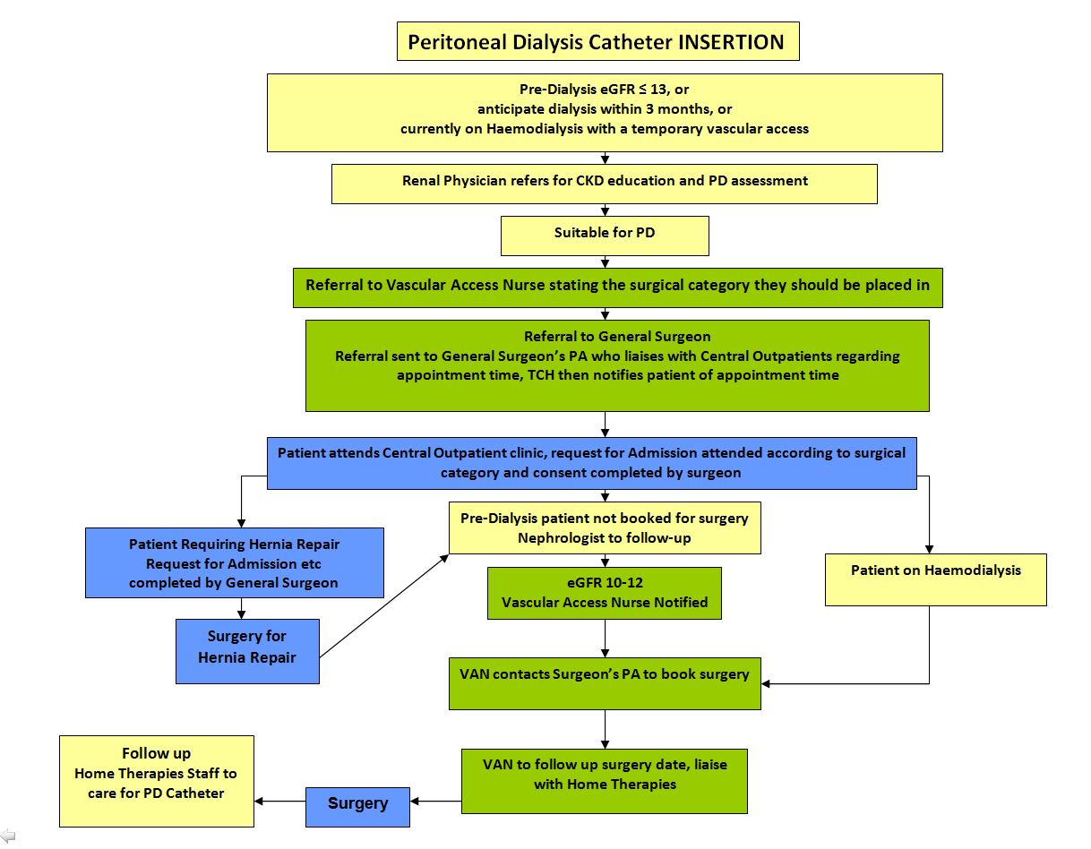

*Back to Table of Contents*

|  |
| --- |
| Section 8 – PD Management of Referral Process for the manipulation or removal of a PD Catheter |

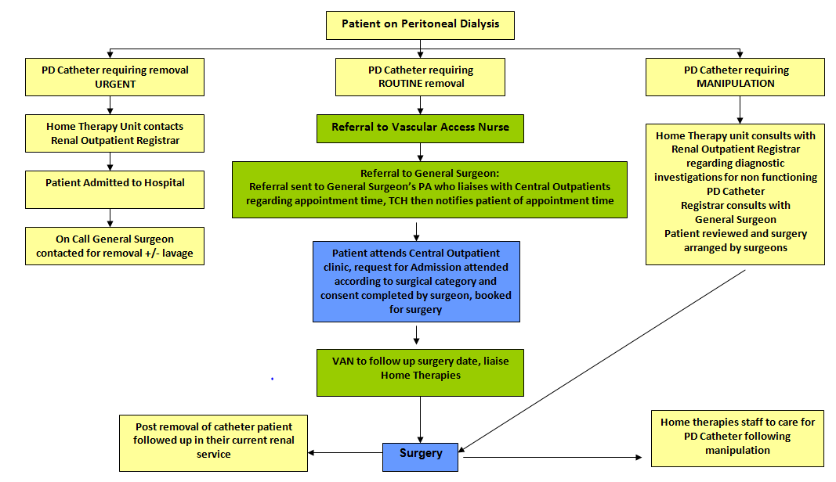

[Type a quote from the document or the summary of an interesting point. You can position the text box anywhere in the document. Use the Text Box Tools tab to change the formatting of the pull quote text box.]

*Back to Table of Contents*

|  |
| --- |
| Implementation |

This guideline will be implemented and communicated to the Renal Network staff by incorporating it into the orientation programs for credentialing Renal Staff. The Vascular Access Nurse (VAN) will oversee the continued review of the Guideline. The implementation of this guideline is governed by the Vascular Access Governance group and the Clinical Nurse Consultants and Nurse Unit Managers across Renal Network.

*Back to Table of Contents*

|  |
| --- |
| Evaluation |

**Outcome Measures**

* Patients with CKD not on dialysis, target eGFR 15, will have placement of a permanent dialysis access before commencement of dialysis.
* Patients with a new AVF or AVG will have monthly follow up of their access by the VAN or dialysis staff.
* Patients on haemodialysis will have access flow measurements recorded by the dialysis staff within two weeks of the first cannulation and then three monthly to measure the access flow on their AVF or AVG. Abnormalities will be reported to the VAN.
* Waiting times for surgery will be tracked to ensure that patients have surgery in a clinically appropriate timeframe. This is measured by the VAN.

**Method**

* VAN will collect data and record in CV5 to measure time frames
* VAN will review this, at a minimum of six monthly, and report to the Director of Renal Services.
* The Director of Renal Services will review the results and determine changes to Operational Guideline.

*Back to Table of Contents*

|  |
| --- |
| Related Policies, Procedures, Guidelines and Legislation |

## Policies

## Procedures

## Guidelines

Clinical Guideline – Access for Renal Replacement Therapy

## Legislation

*Back to Table of Contents*

|  |
| --- |
| References |

http://www.cari.org.au/dialysis_va_list_published.php

http://www.kidney.org/professionals/KDOQI/guideline_upHD_PD_VA/va_guide1.htm

http://www.kidney.org/professionals/KDOQI/guideline_upHD_PD_VA/va_guide2.htm

http://www.esrdnetwork18.org/pdfs/QI%20-%20FF%20Tools/FFTool_CathReduction.pdf

http://jasn.asnjournals.org/content/16/1/201.full.pdf

http://www.kidney.org/professionals/KDOQI/guideline_upHD_PD_VA/index.htm

http://www.ncbi.nlm.nih.gov/pubmed/21326504

http://www.hindawi.com/journals/ijn/2012/649735/

http://www.nwrenalnetwork.org/fist1st/AVFCare.pdf

http://www.kidney.org/professionals/KDOQI/guideline_upHD_PD_VA/va_guide5.htm

http://www.ncbi.nlm.nih.gov/pmc/articles/PMC3036211

http://jasn.asnjournals.org/content/16/1/201.full.pdf

http://www.kidney.org/professionals/KDOQI/guideline_upHD_PD_VA/index.htm

http://www.uptodate.com/contents/placement-and-maintenance-of-the-peritoneal-dialysis-catheter

http://www.health.nsw.gov.au/policies/pd/2011/pdf/PD2011_060.pdf

http://www.health.qld.gov.au/qhpolicy/docs/gdl/qh-gdl-321-6-3.pdf

Thomas Nicola, Renal Nursing. 4th ed.UK. John Wiley and Sons, Ltd.2014

Scottish Renal Nursing Strategy Group (2007). Best Practice statement for the care of arterio-venous fistula and graft. Retrieved July17, 2014, from http://www.srr.scot.nhs.uk/SRNSG/AVFISTULA_BPS_SEP07.pdf

Transplant, urology and nephrology directorate (2012). Guidelines on the management of arterio venous fistula and grafts. Retrieved July 17, 2014, from www.beaumont.ie/media/AVFguidelinefinalcopy1.pdf

*Back to Table of Contents*

|  |
| --- |
| Definition of Terms (if applicable) |

AVF – Arteriovenous fistula

AVG – Arteriovenous graft

CKD – Chronic Kidney Disease

CNC – Clinical Nurse Consultant

HD - Haemodialysis

Recirculation - Access recirculation occurs in conditions of low access flow. The most common cause is the presence of high-grade venous stenosis, which obstruct venous outflow, leading to backflow into the arterial needle

Access flow – is the flow of blood through an AVF or AVG

Transonic – is a machine that measures the access flow rates within an AVF or AVG

AV anatomises – is the area where an artery is joined to the vein to make an AVF or AVG

CKD – Chronic Kidney Disease

VAN – Vascular Access Nurse

GFR – Glomerular Filtration Rate

PA – Personal Assistant

PD – Peritoneal Dialysis

VAN – Vascular Access Nurse

CVC – Central Venous Catheter

RFA – Request for Admission

ACT – Australian Capital Territory

VMO – Visiting Medical Officer

**Arteriovenous fistula**: The surgical creation of an anastomosis between an artery and a vein to allow arterial blood to flow through the vein causing venous engorgement and enlargement for chronic kidney patients requiring haemodialysis.

**Arteriovenous graft:** a synthetic graft implanted subcutaneously and interposed between an artery and a vein allowing needles to be inserted in order to remove and return blood during haemodialysis for patient with inadequate vessels for creation of AV fistula**.**

**Bruit** *-* Bruit (pronounced broo-ee), the sound blood makes as it moves through arteries

**Thrill -**arterial thrill, which is a vibration that is felt over an artery and caused by turbulent blood flow.

**Steal Syndrome -** refers to vascular insufficiency resulting from an arteriovenous fistula or synthetic vascular graft-AV fistula). Some of the symptoms of steal syndrome are cold extremity, decreased capillary refill, severe pain and absence of radial pulse

*Back to Table of Contents*

|  |
| --- |
| Search Terms |

Haemodialysis

Peritoneal Dialysis

Vascular Access

Central Venous Catheter

Steal Syndrome

Thrill

Arteriovenous graft

Arteriovenous fistula

*Back to Table of Contents*

|  |
| --- |
| Consultation |

|  |  |  |  |
| --- | --- | --- | --- |
| **Name/position/Division of person(s) consulted** | **Feedback Received**  **Yes/No** | **Feedback incorporated**  **Yes/No** | **Comment** |
| SNSWLHD Renal CNC and Dialysis Unit NUMs | Yes | Yes | Bring into line with equipment and processes in Dialysis Units in SNSWLHD |
| CHHS Renal Vascular Access Nurse and Renal Outpatient CNC | Yes | Yes | Merge feedback from SNSWLHD |
| Dr Girish Talaulikar  Director Renal Service | Yes |  | No changes |
| CHHS Renal CNCs | No |  |  |
| CHHS Renal Consultants | No |  |  |
| Dr Stephen Bradshaw  Vascular Surgeon | No |  |  |
| Dr Wendel Neilson  Vascular Surgeon | No |  |  |
| Sandra Hruza and Shirynne Cowan  CNC and Ag CNC EDSU | No |  |  |
| Lorraine Erikson  CNC 9A | No |  |  |

*Back to Table of Contents*

|  |
| --- |
| Attachments |

**Attachment 1**



**Disclaimer**: *This document has been developed by Health Directorate, Canberra Hospital and Health Services specifically for its own use. Use of this document and any reliance on the information contained therein by any third party is at his or her own risk and Health Directorate assumes no responsibility whatsoever.*

|  |  |  |
| --- | --- | --- |
| Date Amended | Section Amended | Approved By |
|  |  |  |
|  |  |  |