PRIMARY
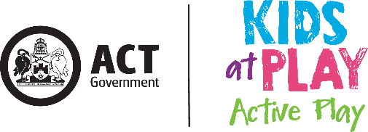

Active Play Audit Tool

A tool developed to assist the ACT Early Childhood Education sector to promote active play to children in schools
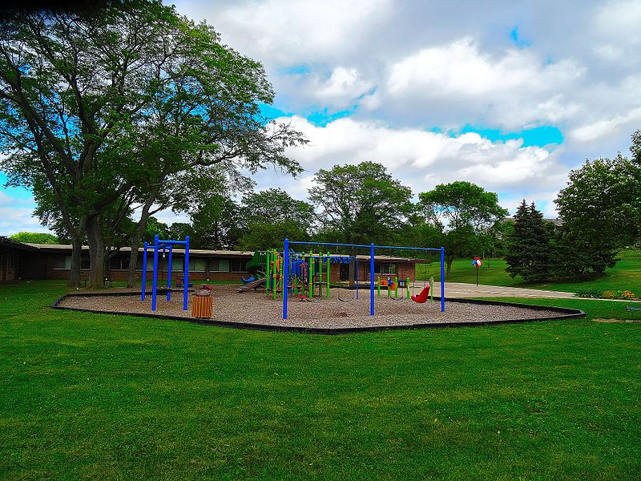

Completing this audit tool will assist your school to:

- Meet requirements of the Learning Achievement Standards within the Australian Curriculum
- Create an action plan to further promote active play in the learning environments.

Audit document approval details
Date approved: (This is the date on which the audit document was approved)
Approver: (List the name and position title of who approved the audit)

This audit tool has been developed to assist teachers to promote physical activity to children in their schools. Teachers can use this audit tool to evaluate their outdoor learning environment. It also provides educators with the opportunity to reflect on current practices and offers guidance to those seeking to improve both the quality of their outdoor learning environment, as well as increase physical activity levels in children.
Why do we need this Audit Tool?

To counteract sedentary lifestyles and obesity, outdoor play is particularly important for young children.
Evaluations undertaken as part of the Kids at Play Active Play have identified barriers in ECEC schools in supporting children’s physical activity in the outdoor learning environment.
Related Research
- ‘Physical activity during the early childhood period is important as that is the time when children can learn and develop healthy behaviours which can then support them throughout their lives’ (Hinkey et al, 2008, pg1)

- Research suggests there is a strong relationship between physical activity levels and time spent outdoors (Hinkley et al, 2008, pg 3)

- ‘Having a high quality outdoor environment is not sufficient to encourage preschool physical activity. The educational approach is critical in facilitating children’s use of the outdoors.’ (Cosco, 2006, p14)
Physical Activity and Sedentary Behaviour Guidelines (5-12 years)
PHYSICAL ACTIVITY
- Accumulate at least 60 minutes of moderate to vigorous intensity physical activity each day
- Include a variety of aerobic activities, including some vigorous intensity activity
- Include muscle and bone strengthening activities on at least days per week
- For more health benefits, include more physical activity each day – up to several hours per day
SEDENTARY BEHAVIOUR
- Minimise time spent being sedentary by:
- Limiting screen time to no more than 2 hours per day
- Breaking up long periods of sitting
Australian Government, Department of Health, (2014)

“As a foundation for lifelong physical activity participation and enhanced performance, students acquire an understanding of how the body moves and develop positive attitudes towards physical activity participation”
Acknowledgements: Australian Curriculum, Assessment and Reporting Authority (ACARA) https://www.australiancurriculum.edu.au/f-10-curriculum/health-and-physical-education

Please note:
Although this audit tool focuses on the outdoor learning environment, we recognise that the indoor learning environment must also be utilised to promote and support children’s physical activity and to meet current standards and curriculum requirements.

Links to the Australian Curriculum
The information below highlights (in colour coding) the elements of KAPAP that are relevant to the Australian Curriculum: Health and Physical Education (HPE) learning area. Of greatest relevance within HPE is the Strand of Movement and Physical Activity (Yellow), which is then divided into three Sub Strands: Moving our body (Blue), Understanding Movement (Red) and Learning through Movement (Green).

Australian Curriculum Achievement Standards (what students will learn)
Foundation
- By the end of Foundation Year (Kindergarten), students recognise how they are growing and changing. They identify and describe the different emotions people experience. They identify actions that help them be healthy, safe and physically active. They identify different settings where they can be active and demonstrate how to move and play safely. They describe how their body responds to movement.
- Students use personal and social skills when working with others in a range of activities. They demonstrate, with guidance, practices and protective behaviours to keep themselves safe and healthy in different activities. They perform fundamental movement skills and solve movement challenges.

Year 1 and 2
- By the end of Year 2, students describe changes that occur as they grow older. They recognise how strengths and achievements contribute to identities. They identify how emotional responses impact on others’ feelings. They examine messages related to health decisions and describe how to keep themselves and others healthy, safe and physically active. They identify areas where they can be active and how the body reacts to different physical activities.
- Students demonstrate positive ways to interact with others. They select and apply strategies to keep themselves healthy and safe and are able to ask for help with tasks or problems. They demonstrate fundamental movement skills in a variety of movement sequences and situations and test alternatives to solve movement challenges. They perform movement sequences that incorporate the elements of movement.

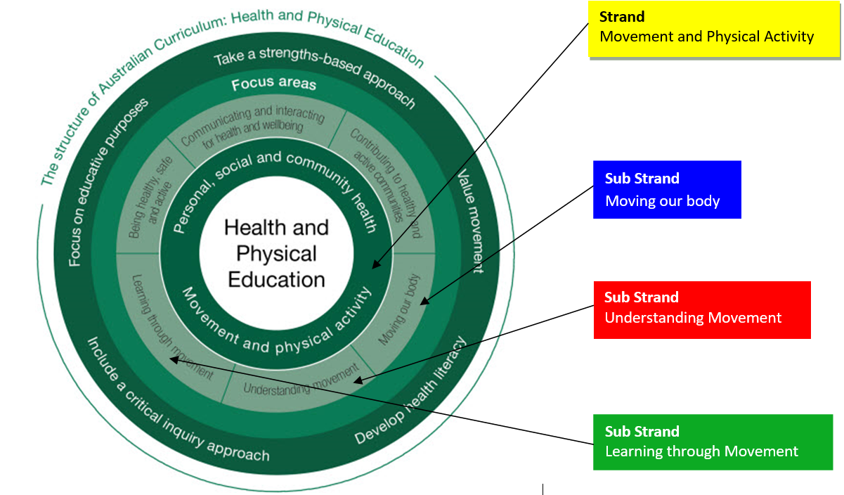

Implementing the Active Play Audit Tool in school settings.

Objectives of the Audit Tool
- To reflect upon the effectiveness of the learning environments in supporting children’s active play.
- To identify gaps in promoting children’s active play in the setting.
- To guide the development of an action plan to further promote active play in the learning environments.

Outline of the Audit Tool

This ‘Active Play Audit Tool’ is divided into 6 sections:

1. Learning Spaces

2. Resources

3. Physical Development

4. Educators

5. Families

6. Additional Essential Elements

How to use the Audit Tool
- Each section begins with a question that asks schools to reflect upon current practices. Record these reflections in the space provided on the audit tool.
- Use the listed considerations to assist with your reflection (e.g. for learning spaces, which of the spaces listed under ‘considerations’ does your school have?)
- Upon completion of this reflection process, record in the ‘Action Plan’ section your school’s strategies for increasing the active play opportunities in the different learning environments.
- Use the listed considerations to assist with developing your action plan (e.g. for learning spaces, are there spaces listed under ‘considerations’ that you do not have and would like to create in the future?)

Audit Tool Implementation Flowchart
Schedule a team meeting to undertake the audit

Ensure each educator receives a copy of the entire audit tool at least 1 week prior to the team meeting.

Each educator must review and reflect upon each section of the audit tool in preparation for the team meeting.

At the team meeting work through the audit tool –including the introduction, followed by the reflective question, considerations and creation of an action plan for each section.

Address strategies in action plans, make changes.
Review again in 6-12 months

Section 1 - Learning Spaces
Reflective Question: What are the learning spaces in our school’s environment?

Considerations:
 | Animal Habitat |  | Dramatic Play |  | Cubby House |  | Quiet space
 | Shaded play area |  | Garden |  | Digging Pit |  | Sandpit
 | Stage / Platform |  | Grass/Open Area |  | Playground |  | Water trough
 | Construction area |  | Hill / Mound |  | Bike Paths |  | Softfall
Action Plan: (What spaces do we have that we are not using? What spaces do we need to create? What changes can we make so that our learning spaces better facilitate active play? How can indoor spaces be modified to create additional play spaces in poor (too hot, too cold, too wet) weather?)

Section 2 - Resources
Reflective Question: Within the identified learning spaces from Section 1, what resources are available to encourage children’s active play?

Considerations:
 | A-frame trestles |  | Climbing trees |  | Scooters |  | Sticks |  | Steps
 | Animal figures |  | Dry creek bed |  | Shade |  | Pipes |  | Streamers
 | Stepping stones |  | Watering cans |  | Tree stumps |  | Bikes |  | Balls
 | Work bench |  | Shovels |  | Pots |  | Spades |  | Shells
 | Wheel barrows |  | Bean bags |  | Camera |  | Buckets |  | Swing
 | Edible plants |  | Hoops |  | Ramps |  | Chalk |  | Targets
 | Scooter Boards |  | Ladders |  | Ribbons |  | Wood |  | Tree logs
 | Books |  | Music |  | Ropes |  | Pebbles |  | Tyres
 | Boats |  | Paint |  | Scarves |  | Photos |  | Trestles
 | Variety of walking surfaces |  | Dramatic play  props |  | Kitchen equipment |  | Loose parts play |  | Trucks
Action Plan: (What resources do we have that we are not using? What resources do we need to get? How can we use recycled materials to make active play equipment? What changes can we make so that our resources better facilitate active play?)

Physical environments at schools should include a range of activity opportunities to support children’s physical activity, including a variety of portable and fixed play equipment and adequate shading. (Hinkley et al, p4)

Section 3 - Physical Development
Reflective Question: During children’s active play, what areas of physical development or Fundamental Movement Skills are being promoted?

Considerations : (Areas of physical development)
 | Muscle strength |  |  |  | Coordination eye-hand |  |  |  | Flexibility |  | Walking
 | Body awareness |  |  |  | Coordination eye-foot |  |  |  | Dexterity |  | Cross-patterning
 | Agility |  |  |  | Cardiovascular fitness |  |  |  | Skipping |  | Bone strength
 | Balance |  |  |  | Spatial awareness |  |  |  | Posture
Considerations : (Fundamental Movement Skills)
 | Hopping |  | Stationary dribbling |  |  |  | Catching |  |  |  | Galloping
 | Running |  | Overarm throwing |  |  |  | Underarm rolling |  |  |  | Side sliding
 | Jumping |  | Striking a stationary ball |  |  |  | Kicking |  |  |  | Leaping
Action Plan: (What areas of physical development or fundamental movement skills do the children in our care need to be working on? Are there specific skills that need to be taught? Are there games or activities we can introduce to the children to promote the development of specific physical skills?)

Section 4- Educators
Reflective Question: As an educator, how do you support children’s active play and physical development through the identified learning spaces and resources?

Considerations : (Interactions)
 | Individual – one to one |  | Shared – small group |  |  |  | Shared – large group
Considerations : (Role modelling)
 | Curiosity |  | Enthusiasm |  |  |  |  | Participation
 | Demonstration |  | Imagination |  |  |  |  | Passion
Considerations : (Other)
 | Accessing community resources (built, space, human) |  | Awareness of children’s individual needs |  |  | Scaffold children’s physical skills
 | Embedding active play into the everyday curriculum |  | Observational recordings and evaluations |  |  | Provide positive constructive feedback
 | Being aware of spontaneous opportunities |  | Include active play in professional conversations |  |  | Conversations with families
 | Provide opportunities for risk taking and challenge |  | Planning intentional experiences (GMS and FMS) |  |  | Provide quality & sufficient resources
 | Sharing with children the benefits of being active |  | Building on children’s interests |  |  | Being culturally inclusive
 | Including children in planning and set-up of active play |  | Excursions/ incursions
Action Plan: (What changes do we need to make to the way we interact with children and model active play? Are there opportunities or experiences that we need to include in our program to better facilitate active play?)

Section 5 - Family
Reflective Question: How do we share with families the importance of active play?

Considerations :
 | Being an active role model |  | Conversations with families |  | Daily diary / journal
 | Embed active play into classroom activities |  | Family active play journal to share with class |  | Noticeboards / Photos / Newsletters
 | Invite families to participate in physical experiences |  | Invite families to share their active play interests |  | Special active play events
Action Plan: (How can we be better at sharing the importance of active play with families and supporting them to engage in regular active play with their children?)

Section 6- Additional Essential Elements
Reflective Question: What additional essential elements need to be considered in supporting active play in the learning environment?

Considerations :
 | Adequate shade |  | Australian Curriculum |  | Sustainability
 | Adequate space |  | Physical Activity Policy |  | Supervision
 | Ample time |  | Physical activity recommendations |  | Cost effectiveness
 | Appropriate clothing |  | Workplace Health & Safety |  | Sunsmart guidelines
 | Routines |  |  |  | Appropriate footwear
Action Plan: (What else can we do to better facilitate active play at our school? Do we have a physical activity policy? If not, complete the Physical Activity and Screen Time Policy.)

‘Cancer Council ACT recommends SunSmart behaviour when daily UV levels reach 3 and above. Sun protection is generally not recommended in Canberra during June and July or when UV levels are low (under 3).’

References

Australian Curriculum, Assessment and Reporting Authority 2010 (ACARA). Australian Curriculum website (www.australiancurriculum.edu.au).

Australian Government, Department of Health and Ageing (2014) Make Your Move – Sit less. Be active for life. Physical Activity and Sedentary Behaviour Guidelines (5-12 years). Canberra

Cancer Council ACT (2016) Cancer Council’s National SunSmart Early Childhood Program www.actcancer.org/prevention/sunsmart/act-schools-and-early-childhood-schools/national-early-childhood-program/

Cosco, N. (2006) Motivation to Move: Physical Activity Affordances in preschool Play Areas. Heriot Watt University. Edinburgh

Hinkley, T & Salmon, J. (2011) Correlates of Physical Activity in Early Childhood. Encyclopedia on Early Childhood Development.

