Height, Weight & Body Mass Index (BMI) Measurements
Your child has just completed their Kindergarten Health Check. This included measuring their height and weight with their jumper and shoes removed. Your child’s Body Mass Index has been calculated and written on their results letter. Your child was not informed of the results.
This measurement of height, weight and BMI is a guide to indicate whether a child is above or below their healthy weight range.

- The BMI is an approximate measure of the best weight for your child’s health
- The formula used to calculate BMI is the same for adults and children but the classification is different, taking into account your child’s age and gender
- BMI can identify children who may be at risk of health problems in childhood and later life

Your result sheet includes a BMI range shown by coloured circles. The in the coloured circle indicates where your child’s BMI sits on the percentile scale for their age and gender.

If your child’s weight is outside the healthy weight range or if you have concerns about your child’s growth, it is important for you to follow up with your General Practitioner (GP) or a dietitian for further assessment.
- ACT Health has dietitians who can provide tailored assessment and advice on growth and nutrition. Appointments can be made by contacting Community Health Intake on 6207 9977. This service is free
- GPs can assess your child’s overall health taking into account family history and their current weight and growth pattern
- Private dietitians can be found using ACT Health’s Find A Health Service http://findahealthservice.act.gov.au

For all families, a copy of the ACT Health Tuckatalk newsletter, Healthy Lifestyles for Healthy Bodies, is enclosed. The newsletter provides information on family eating, healthy food choices and physical activity.
Further information on the Kindergarten Health Check including height, weight and BMI and healthy lifestyles for children can be found at this website
https://www.health.act.gov.au/services-and-programs/women-youth-and-children/children-and-youth/school-health

For further assistance please phone the School Health Team on 5124 1585.

Additional Information about BODY MASS INDEX

The Body Mass Index (BMI) is a snapshot of where your child sits on a BMI growth chart. When you receive a Parent Results letter it may indicate that your child’s BMI is outside the Healthy Weight range. Children’s weight and BMI often varies during normal growth and stages of development.

‘Overweight and obesity are significant issues for some children. If you help children deal with these issues during childhood, they’re less likely to have problems with overweight and obesity later in life’ (raising children.net.au)

If you would like to re-check and monitor your child’s BMI the calculator can be found at: https://www.cdc.gov/healthyweight/bmi/calculator.html

For further Resources about helping children maintain a healthy weight;
Capital Health Network ‘Connect up 4 Kids’
https://www.chnact.org.au/connect-up-4-kids-family-resources
Raising Children Network
http://raisingchildren.net.au/articles/childhood_obesity.html
Women and Children’s Network, Parenting & Child Health
http://www.cyh.com/HealthTopics/HealthTopicDetails.aspx?p=114&np=302&i d=1498
Better Health Victoria
https://www.betterhealth.vic.gov.au/health/healthyliving/obesity-in-childrencauses
Healthy Kids Association
http://healthy-kids.com.au/parents/developing-positive-eating-behaviours/

ACCESSIBILITY
If you have difficulty reading a standard printed document and would like an alternative format, please phone 13 22 81.
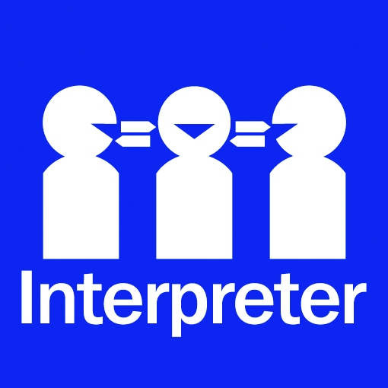 | If English is not your first language and you need the Translating and Interpreting Service (TIS),  please call 13 14 50.  For further accessibility information, visit: www.health.act.gov.au/accessibility
www.health.act.gov.au | Phone: 132281 | Publication No 2016
© Australian Capital Territory, Canberra July 2016

